Experiment 4: Conditional Control Statements in PL/SQL

1. Aim of the Session
The aim of this practical is to design and implement PL/SQL programs using conditional control statements such as IF–ELSE, IF–ELSIF–ELSE, ELSIF ladder, and CASE statements in order to control the flow of execution based on logical conditions.
Purpose of the Practical:
- To understand decision-making constructs in PL/SQL
- To learn how conditional statements control program flow
- To analyze different types of conditional structures
- To implement real-world decision logic using PL/SQL

2. Objective of the Session
The specific objectives of this experiment are:
- To understand conditional control statements in PL/SQL
- To learn the syntax and usage of IF–ELSE and IF–ELSIF–ELSE
- To implement ELSIF ladder for multi-condition evaluation
- To use CASE statements for fixed-value comparisons
Upon completion, students will be able to:
- Write PL/SQL programs involving conditional logic
- Select appropriate control structures based on problem requirements
- Implement decision-making logic efficiently
- Execute and debug PL/SQL programs in Oracle environment

3. Practical / Experiment Description
This experiment demonstrates the use of conditional control structures in PL/SQL, which allow the execution of different code blocks depending on whether specified conditions evaluate to TRUE or FALSE.
The experiment includes the following conditional constructs:
- IF–ELSE – Used for binary decision making
- IF–ELSIF–ELSE – Used for multiple condition evaluation
- ELSIF Ladder – Used to evaluate a range of conditions sequentially
- CASE Statement – Used for fixed-value comparison
The program performs various checks such as:
- Determining whether a number is positive or non-positive
- Evaluating grades based on marks
- Determining performance status
- Displaying the day name based on day number

4. Procedure of the Practical
Follow the steps given below to execute the experiment:
(i) Start the System and Open DBMS
- Power on the system
- Open Oracle Live SQL / Oracle SQL Developer
- Connect using valid database credentials

(ii) Enable Output Display
SET SERVEROUTPUT ON;
This command enables the display of output generated by PL/SQL programs.

(iii) Write the PL/SQL Program
SET SERVEROUTPUT ON;

DECLARE
num NUMBER := 5;
marks1 NUMBER := 82;
marks2 NUMBER := 68;
day_num NUMBER := 4;
BEGIN
IF num > 0 THEN
DBMS_OUTPUT.PUT_LINE('The number ' || num || ' is POSITIVE');
ELSE
DBMS_OUTPUT.PUT_LINE('The number ' || num || ' is NON-POSITIVE');
END IF;

IF marks1 >= 90 THEN
DBMS_OUTPUT.PUT_LINE('Grade: A');
ELSIF marks1 >= 75 THEN
DBMS_OUTPUT.PUT_LINE('Grade: B');
ELSIF marks1 >= 60 THEN
DBMS_OUTPUT.PUT_LINE('Grade: C');
ELSE
DBMS_OUTPUT.PUT_LINE('Grade: FAIL');
END IF;

IF marks2 >= 85 THEN
DBMS_OUTPUT.PUT_LINE('Performance: Excellent');
ELSIF marks2 >= 70 THEN
DBMS_OUTPUT.PUT_LINE('Performance: Very Good');
ELSIF marks2 >= 55 THEN
DBMS_OUTPUT.PUT_LINE('Performance: Good');
ELSIF marks2 >= 40 THEN
DBMS_OUTPUT.PUT_LINE('Performance: Average');
ELSE
DBMS_OUTPUT.PUT_LINE('Performance: Poor');
END IF;

CASE day_num
WHEN 1 THEN DBMS_OUTPUT.PUT_LINE('Monday');
WHEN 2 THEN DBMS_OUTPUT.PUT_LINE('Tuesday');
WHEN 3 THEN DBMS_OUTPUT.PUT_LINE('Wednesday');
WHEN 4 THEN DBMS_OUTPUT.PUT_LINE('Thursday');
WHEN 5 THEN DBMS_OUTPUT.PUT_LINE('Friday');
WHEN 6 THEN DBMS_OUTPUT.PUT_LINE('Saturday');
WHEN 7 THEN DBMS_OUTPUT.PUT_LINE('Sunday');
ELSE
DBMS_OUTPUT.PUT_LINE('Invalid Day Number');
END CASE;
END;
/

(iv) Execute the Program
- Run the program using /
- Observe the output displayed in the output window

(v) Verify the Result
- Ensure correct messages are displayed for each condition
- Confirm that control statements execute as expected

5. Input / Output Analysis
Inputs Provided:
- num = 5
- marks1 = 82
- marks2 = 68
- day_num = 4
Operations Performed:
- Comparison of numeric values using IF–ELSE
- Grade evaluation using IF–ELSIF–ELSE
- Performance analysis using ELSIF ladder
- Day selection using CASE statement
Output Generated:
- Number is POSITIVE
- Grade: B
- Performance: Good
- Thursday
SCREENSHOTS OF THE OUTPUT ARE ATTACHED BELOW
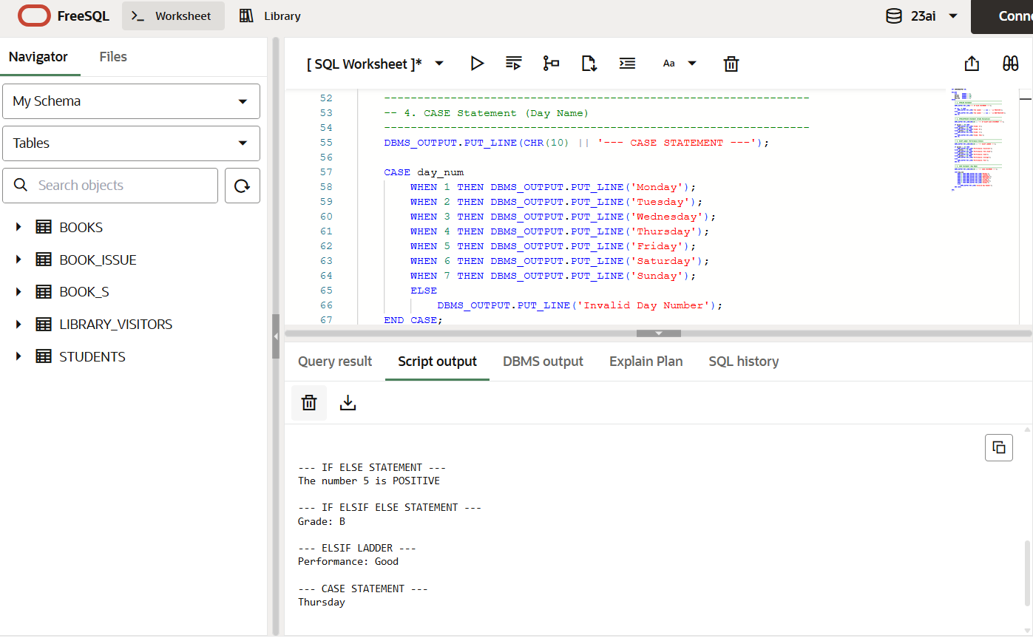

6. Learning Outcomes
Concepts Understood:
- Conditional control statements in PL/SQL
- Logical comparison and branching
- Syntax and usage of IF, ELSIF, and CASE
Skills Developed:
- Writing structured PL/SQL programs
- Implementing decision-making logic
- Using DBMS_OUTPUT for displaying results
- Debugging conditional statements
Practical Exposure Gained:
- Hands-on experience with PL/SQL control structures
- Understanding execution flow in procedural SQL
- Working with Oracle PL/SQL environment

7. Result
Thus, PL/SQL programs demonstrating IF–ELSE, IF–ELSIF–ELSE, ELSIF ladder, and CASE statements were successfully designed, executed, and verified. The experiment effectively illustrated decision-making capabilities in PL/SQL.

